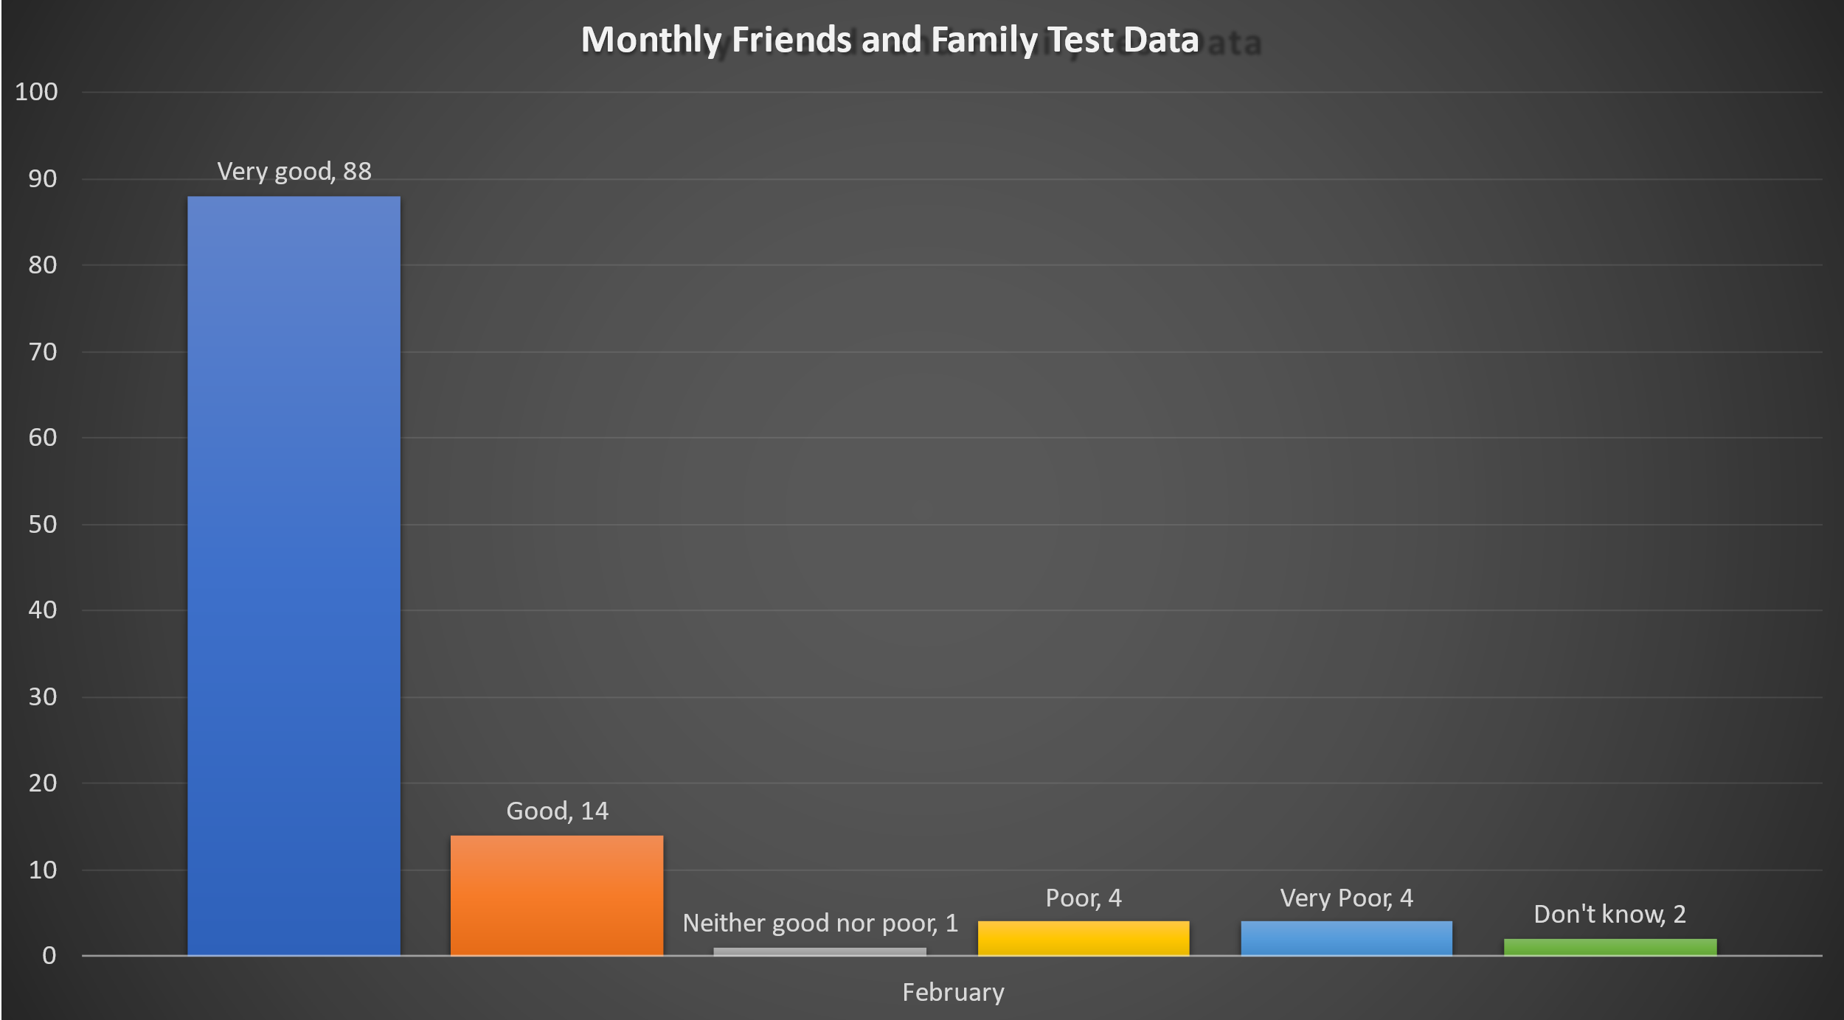
Very Good: 88
Good: 14
Neither good nor poor: 1
Poor:
Very poor: 4
Don’t know: 2

